**WORK INSTRUCTIONS FOR OPENING OF PLUGGED TUYERE ON MINIMUM BLAST**

Responsibility: Shift superintendent /Cast house in charge/ Foreman

**Identified Hazards:**

1. Fall, slip of a person
2. Mechanical impact
3. Contact with graphite dust
4. Fire & Explosion in the gas line
5. BF Gas leakages
6. Contact with flame
7. Contact with hot metal/slag
8. Contact with hot water
9. Human behavior-PPE’s noncompliance.
10. Improper house keeping
11. Inadequate local lighting
12. Human Behavior -Not using CO detector
13. Human behavior-Working in a hurry and getting hurt
14. Dust inhalation
15. Contact with hot surface
16. Contact with hot coke
17. Gas leakage due to improper sitting of tuyere/cooler/cooler holder
18. Human behavior-SOP violation
19. Human behavior-Ignorance, casual approach

Significant Aspect:

1. Emission of BFG

2. Usage of water

3. Generation of dust

4. Noise generation

1. Unauthorized operation or repair of any equipment is a punishable offence.
2. Any unauthorize entry to cast house is prohibited, only trained cast house operator allowed to carry out the activity
3. Strictly PPE compliance to ensure, Operators carrying out activity must wear full PPE gears such as Leather overcoat, safety shoes, leg guard, safety goggle, helmet with screens, ear plug or earmuff leather hand gloves etc.
4. Authorized or designated cast house tools to be used for the activity, such as rod spear, arrow, sledgehammer etc.

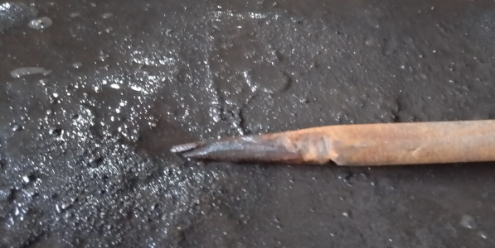 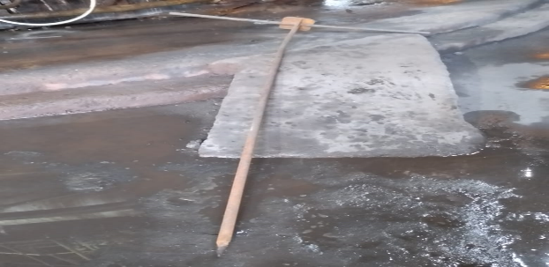

1. Ensure Proper coordination/supervision between SS, cast house in charge, control room in charge, Foreman, operators & fitter for carrying out this activity
2. Ensure casting is dry, furnace is hot and FeO in slag is less than 1% and metal temperature >1380ºC for previous two consecutive casts.
3. After cast closing, reduce wind to 5000-6000 NM3/Hr by closing IVC and further reduce Hot blast pressure to 0.3 - 0.4 bar by opening snort valve simultaneously monitoring the open tuyeres so that there is no slag seen in any open tuyeres. In case slag ingress is observed while reducing wind and pressure in any of the open tuyeres, activity to be called off immediately and wind volume to be increased.
4. If tuyere opening is decided upon and wind and blast pressure is reduced, clearance is given to trained fitter to open front peephole glass assembly. Fitter should also have PPEs such as helmet, overcoat, earmuffs, face shield.
5. Ensure no one is standing Infront of tuyeres/ blowpipe which is to be open
6. Insert tuyere opening rod through the open front tuyeres assembly and it is to be hammered from backend while standing aside from line of fire
7. Do not keep rod inside blowpipe for a longer time to avoid it getting red hot because of high temperature
8. When rod gets inserted to the marked length immediately take it outside, close the front peephole glass assembly.
9. Tighten the peephole assembly bolts and observe tuyeres to check if it has got opened, if not activity can be repeated.
10. If it is opened, gradually increase to desired wind volume and Hot blast pressure,
11. Ensure during whole activity nobody should be in line of fire of the open flange.

|  |  |  |
| --- | --- | --- |
| Prepared By:  Head – Production PID I | Reviewed & Issued By:  Management Representative | Approved By:  Head – Pig Iron Division |
| Signature: | Signature: | Signature: |
| Date: 15**.07.2022** | Date: 15**.07.2022** | Date: 15**.07.2022** |

|  |  |  |  |
| --- | --- | --- | --- |
| **Amendment Record** | | | |
| **Revision date** | **Manual Section ref. and para** | **Brief details of revision** | **New Revision No.** |
| 15.07.2022 | Work instructions for opening of plugged tuyere on minimum blast | Change in format | 01 |